# Lab00 - Routing and Windows

| 💡This lab will rely on some of the skills you have already learned in Systems Administration 1 and Network Protocols. You will build a simple network that will serve as the foundation for future labs. It is important that you make this a reliable build that you have total familiarity with because subsequent activities will use this architecture as a point of departure. |
| --- |

Our goal is to build a realistic server environment consisting of a routed network (LAN and WAN) as well as introduce Server 2019 Desktop and Core and the systems required to manage them.

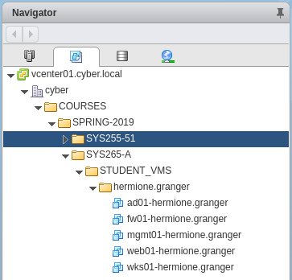

The figure below shows your lab architecture after Parts 1 and Parts 2 of the lab are complete. In part 1, you will establish routing and concentrate on the Windows portions of the Architecture.

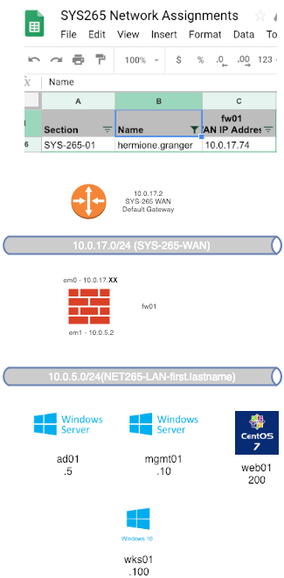

# Requirements

### FW01

Firewall 1 is a pfSense virtual router that you will need to configure in order to route traffic between your private network and the SYS265-WAN (Wide area network) You will have two network interfaces. One will be connected to SYS265-WAN and the other to SYS265-LAN-your.name where your other systems will be hosted.

You will have your own IP address for the shared SYS-265-Network Assignments on the home page.

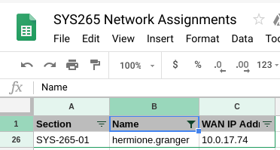

Virtual Networking

The following screenshot shows the appropriate virtual network configuration for fw01.  
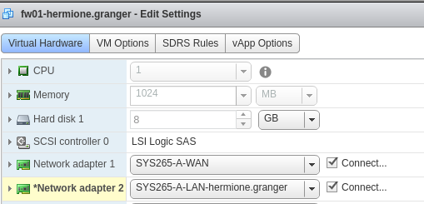

OS Configuration

Configure pfSense similarly as you did during SYS255. If you run into trouble, here's the link to the [SYS255 Lab that covers pfSense](https://drive.google.com/open?id=1a-Kwc611NmL5LO5RuOpHpx0TWYslicZX). A couple pointers:

* It will take a minute or so for a timeout to occur when configuring interfaces. It is waiting for a dhcp server that just does not exist.
* We are not using VLANs
* VMX0/em0 and VMX1/em1 are WAN and LAN respectively
* Your WAN interface will be set to your assigned IP, while the LAN IP will be set to 10.0.5.2/24
* Your WAN upstream gateway address is 10.0.17.2
* We are not using IPv6 on WAN nor LAN
* We are not using the firewall for DHCP on the LAN
* Do not revert to http

When done, your console should look similar to this:

| 💣Do not use Hermione's WAN IP (.74), use your own! |
| --- |

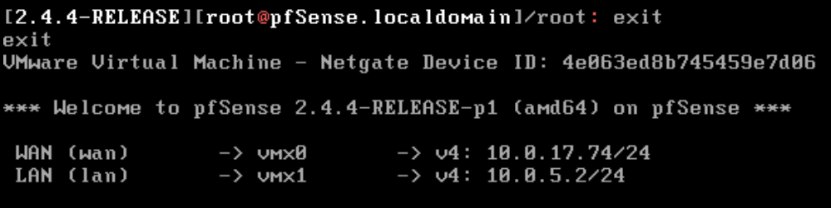

We will complete our configuration using the web interface from our Windows 10 system (wks01)

You should also be able to enter a shell (8) and ping google.com

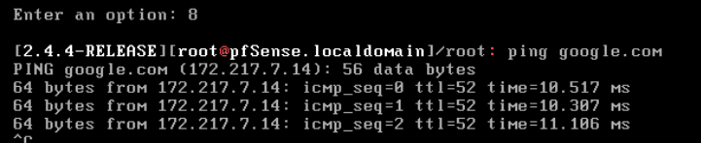

### WKS-01

Virtual Networking:

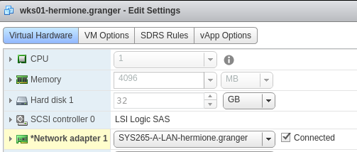

OS Configuration:

| 💡The Windows 10 desktop system (wks01) will display the *champuser* username, which is our deployer account. You will need to set up a new Local Named Administrator account, which you will use for the rest of the term.  Here are [specific instructions](https://docs.google.com/document/d/1mnjUIZ1UqK6Klw2ZKlOs8Gf7nMETFqud6lb-eIyD2HE/edit?usp=sharing) on how to add a new Local Named Administrator account. |
| --- |

Go through the normal configuration steps:

* During 1st boot, the setup asks to “Connect Now to Save Time Later” > Select **No**
* Username: yourname (you may need to add a new local administrative user)
* Adjust your privacy settings by turning everything off when prompted
* Give wks01 a static IP address of 10.0.5.100, netmask of 255.255.255.0 and a gateway and DNS of 10.0.5.2 (your fw01 LAN interface).
* Give your system a hostname of wks01-yourname.

| 💡Pro Tip |
| --- |

Navigate to https://10.0.5.2 and login using admin/pfsense

Follow the FW wizard and make the following changes:

* hostname:fw01-yourfirstname
* Domain: yourfirstname.local
* Primary DNS Server 8.8.8.8
* Uncheck block RFC1918 Private Networks (Step 4)
* If you change the password, take steps to remember it

Your Windows 10 system, WKS01, should be able to ping your LAN's default gateway 10.0.5.2 and resolve and ping google.com

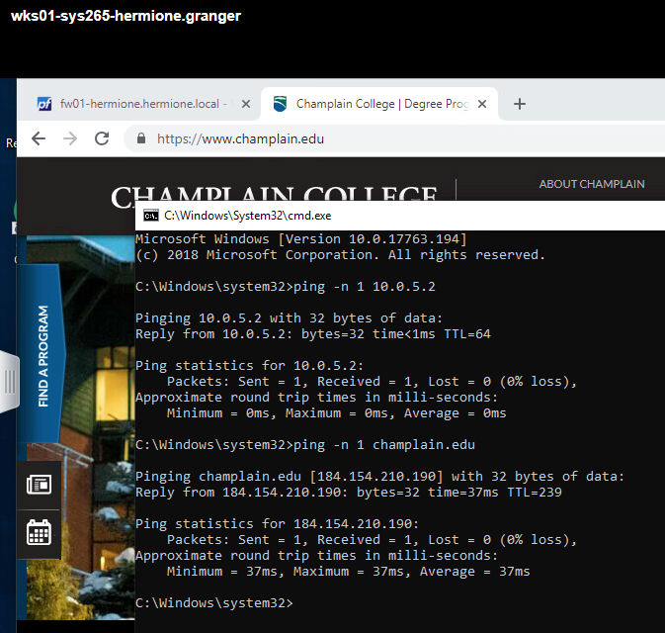

## AD01 - Server Core

Make sure AD01 is on your SYS265-LAN network



Change and record the new administrator password for the Server Core machine.

Using sconfig, configure the following:

Network Settings

IP: 10.0.5.5

Netmask: 255.255.255.0

Gateway: 10.0.5.2

Preferred DNS: 10.0.5.2

Computer Name: ad01-yourname

Manual Windows Update

| 💣This is important, renaming your server after AD installation is a recipe for disaster! |
| --- |

When rebooted, the sconfig screen should look similar to:

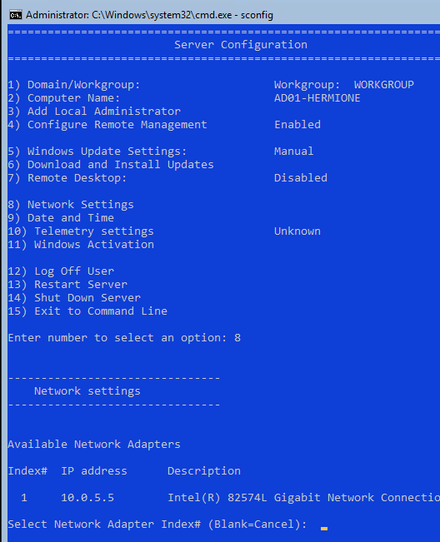

### Installing AD on Server Core.

In previous courses, you have relied on the GUI to install AD. This time, we will use powershell.

On AD01, invoke Powershell and use the CLI to install Active Directory and create a new Forest with a Domain Name of yourfirstname.local (not hermione.local…)

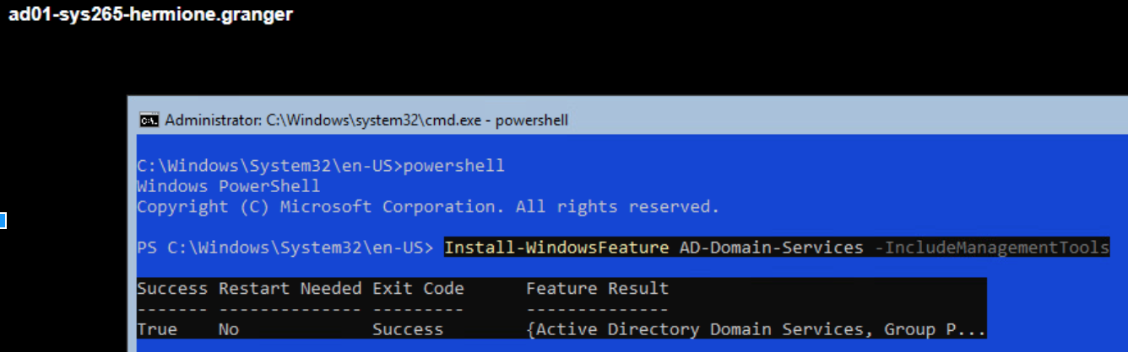

Install the Forest with the following command:

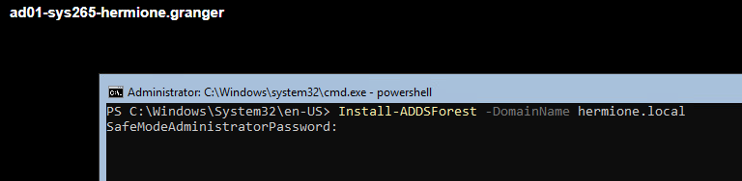

Read through the install prompts, and it will take some moments & of course an auto reboot.

When complete, you should be able to show that you are the Domain Admin account of yourname.local, and NOT the Local Admin Pre-AD account (this Local Admin account is suppressed on Domain Controllers, but not on Member Servers or Clients):

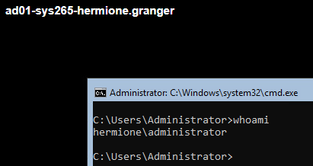

## Configure MGMT01

MGMT01 is a Server 2019 with GUI. It's job will be to remotely manage any server core systems. It should be configured with Network Adapter 1 on SYS265-LAN-your.name just like the other LAN based VMs.

| 💡If you are asked for an activation key, skip that option. |
| --- |

* Using sconfig from command prompt, make updates manual
* MGMT01 should have the IP address of 10.0.5.10
* gateway of 10.0.5.2
* DNS should be set to the IP of ad01(10.0.5.5)
* Hostname should be mgmt01-firstname
* Join it to yourname.local

After rebooting mgmt01, make sure you login to the domain and not the local host.

On MGMT01, figure out how to Install the following Features on mgmt01:

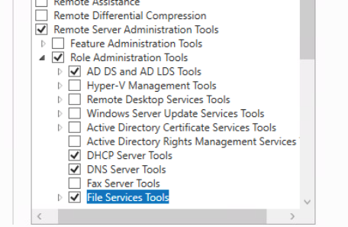

Using Server Manager on mgmt01, add ad01 to the list of managed servers.

### Domain Users

Using Active Directory Users and Computers, create the following named users

first.lastname (normal user)

first.lastname-adm (named domain admin)

Add your -adm account to the Domain Admins group

### DNS

Create a Reverse Lookup Zone for the 10.0.5 network

Create an A record and PTR record for fw01-yourname

Manually add the PTR records for ad01 and mgmt01. Your PTR records should look similar to this:

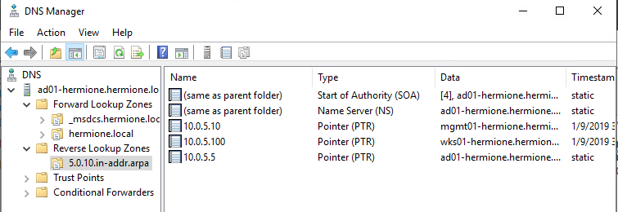

On MGMT01, logout and then re-login as your -adm@yourdomain account.

## Joining WKS01 to the domain

Go ahead and join wks01 to the domain as your Named Domain user. **What needs to be changed to facilitate these changes?**

Deliverable 1: Invoke powershell on mgmt01 and query the active directory for your three Windows computers:

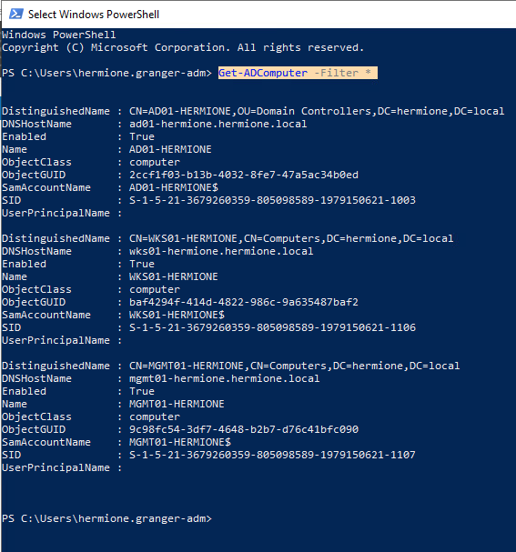

###### Deliverable 2: Enumerate your two named Domain Users (adjust filter for your name)

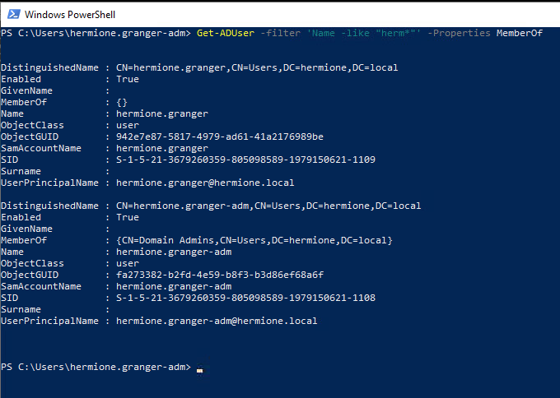

###### Deliverable 3: Print your DNS Server address and DNS A Records.

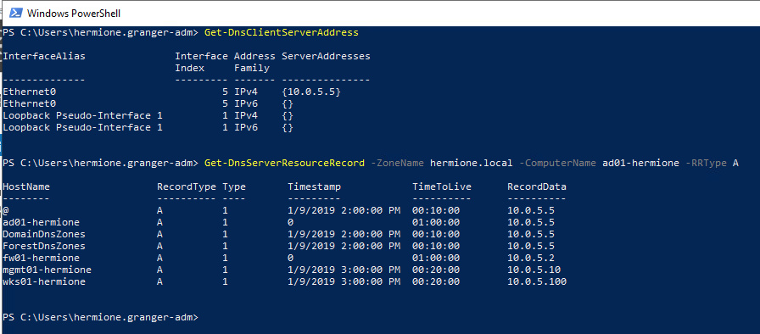

###### Deliverable 4: Check the first 3 hops of your route. Your network route should go through fw01's LAN interface(10.0.5.2) to the WAN default gateway 10.0.17.2 and then out through the CYBER.LOCAL default gateway on the 192.168.4.0/24 Network. You can use the powershell or the traditional tracert method. Provide a screenshot.

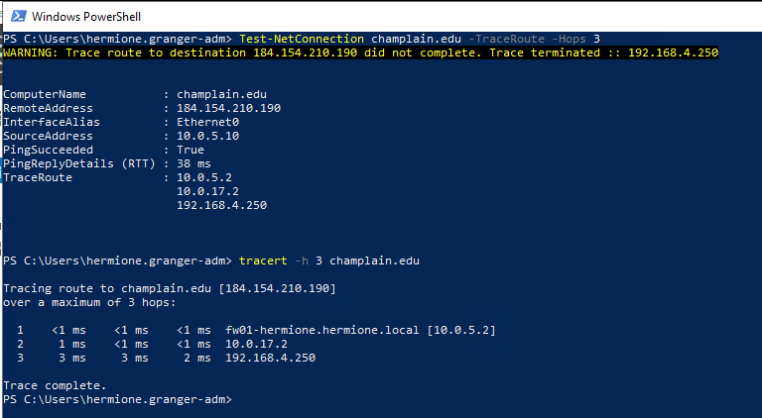

###### Deliverable 5: Deliverable 3 asked for A records. Figure out how to enumerate all the PTR records. Provide the command and output ptr records. Here's what the output should look like:

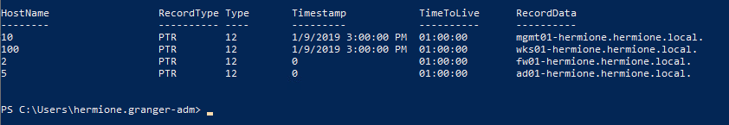

###### Deliverable 6: Tech Journal - This is similar to last term. This week’s journal should include a course journal page for SYS265 that has an initial entry, and include your notes from your environment configuration (in far more detail than [the example](https://docs.google.com/document/d/15935CBHdafNCdXGSFp6LLo6s3EaYpaSxejMNjF8Pzds/edit?usp=sharing)). Make sure you include a list of at least 3 terms or topics from the lecture or lab that you want to learn more about, and your research results. Be sure to add your instructor’s GitHub account as a collaborator if your wiki is not public.

###### 

###### Deliverable 7. Your deliverable meets the submission [guidelines](https://docs.google.com/document/d/1Mbjso3I5UD5bAm2SZisjxO6aqM3ao9mRbqnbAAfjmto/edit).